**How to create a Keil workspace from SPL?**

---STM32 F103 VC for example

Workspace is a space contains necessary files for a particular project, usually a folder. The document aims to provide a step by step method to create a workspace folder that can be a template for most STM32 F1XX projects.

**Navigator:**

0. Pre-request:

1. Initialize your workspace:

2. Setup your environment:

3. Setup your ST-Link:

Appendix

**0. Pre-request:**

a. First, you need a Standard Peripheral Library (SPL) for your device. Go download from ST website!

b. Of course you should complete Keil installation.

c. There are some references you should have a look at…

i. some notes

ii. official docs

**1. Initialize your workspace:**

a. build a workspace folder with following structures: (All the files can be found in SPL, just use Ctrl+F)

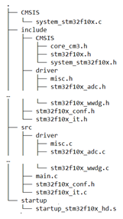

File structure.

Hint: 1. “…” means all the files in the same directory

2. startup_stm32f10x_hd.s has various version, we will use one locate in /3.5.0/STM32F10x_StdPeriph_Lib_V3.5.0/Libraries/CMSIS/CM3/DeviceSupport/ST/STM32F10x/startup/

3. When using stm32f103c8 or c6, we will use startup_stm32f10x_md.s (for c8) or startup_stm32f10x_ld.s (for c6)

b. create a keil project located in the workspace folder.

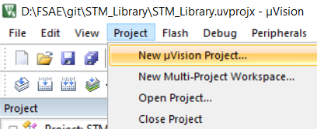

Step 1: Create a project

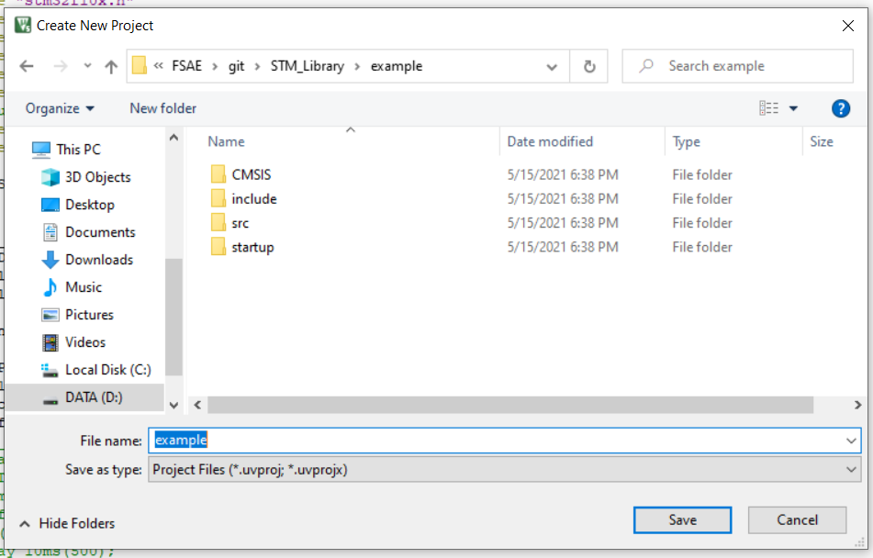

Step 2: Name and locate your project

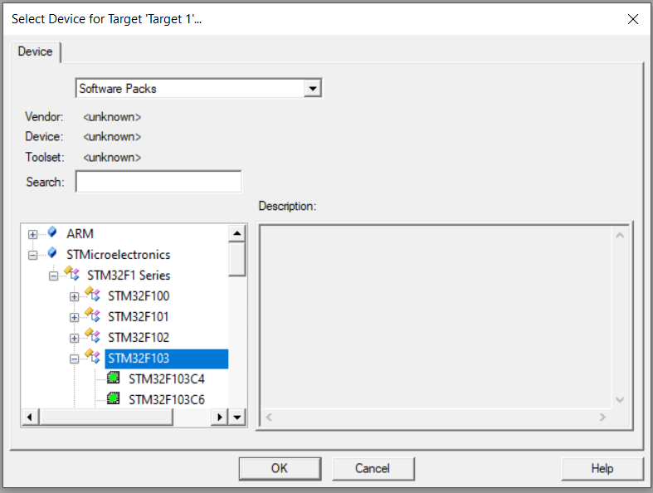

Step 3: choose a STM type that fit your device

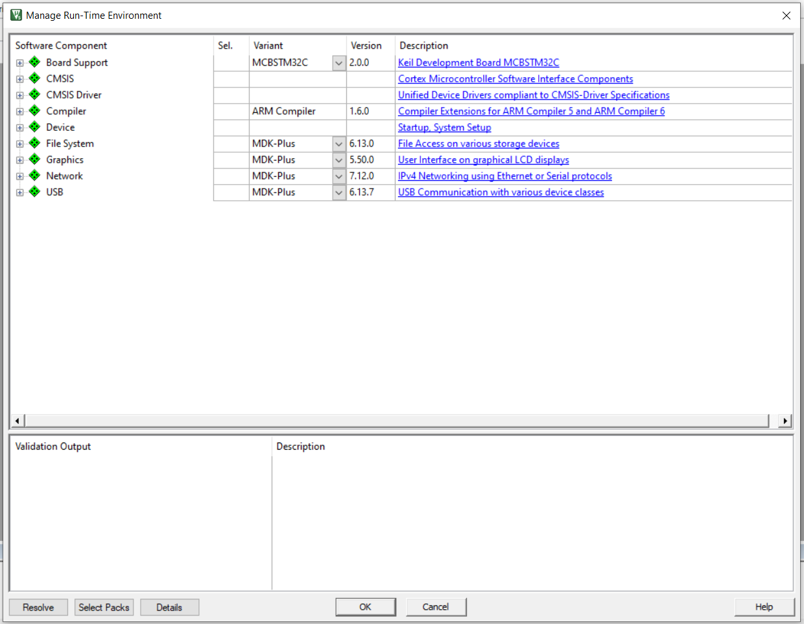

Step 4: Just press OK

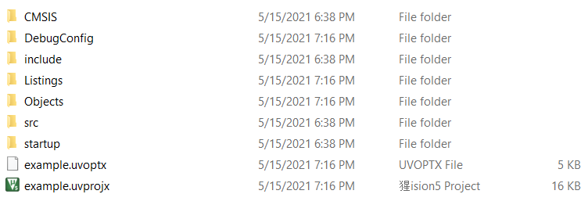

Step 5: Workspace after project creation. Check it out.

**2. Setup your environment:**

a. Configure source groups: Source groups are where Keil finds source files(.c/.s)

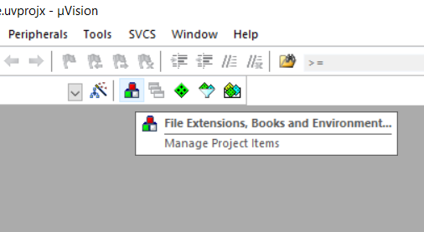

Step 1: Let’s tell Keil where should it find sources to compile

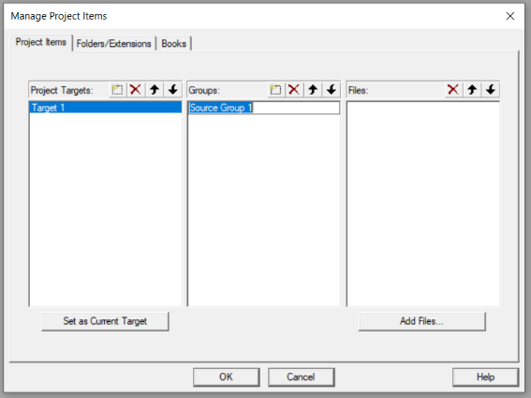

Step 2: Rename source group by double click

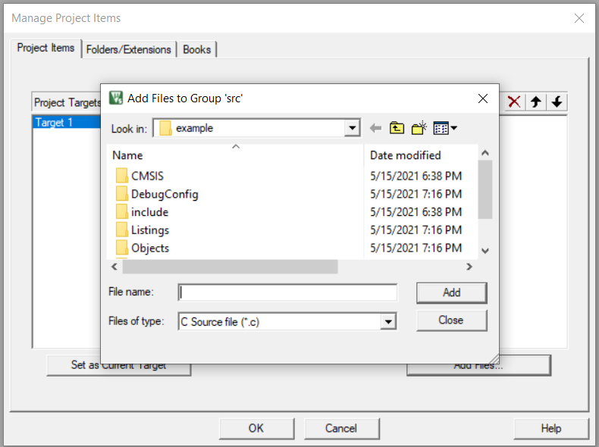

Step 3: Click “Add Files…”, then add source files (.c/.s) to corresponding groups.

Hint: .s is assembly files

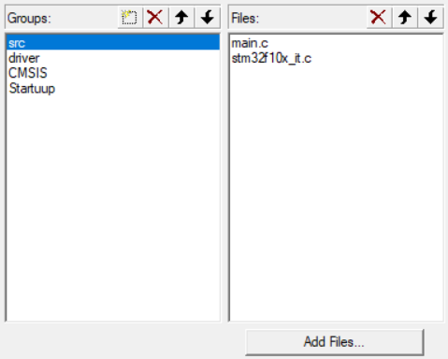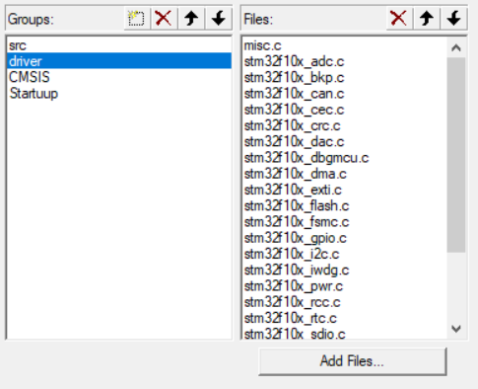

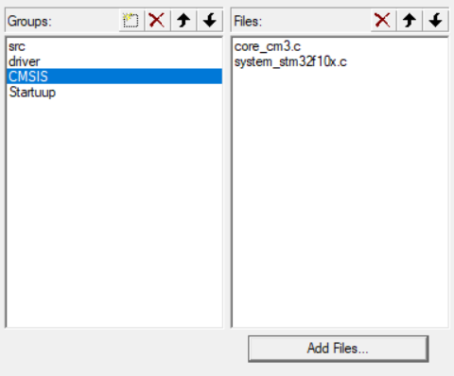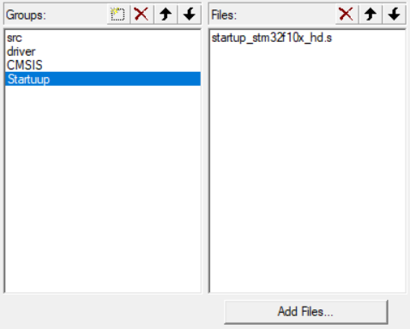

Step 4: Check the source groups are added as above (Don’t mind the blue block)

b. configure “options for targets”

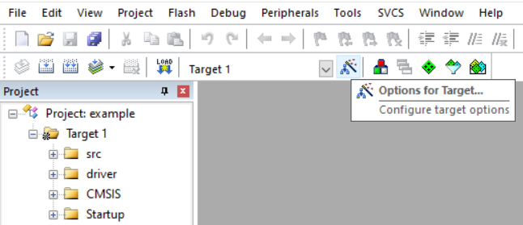

Step 1: Click “Options for target”

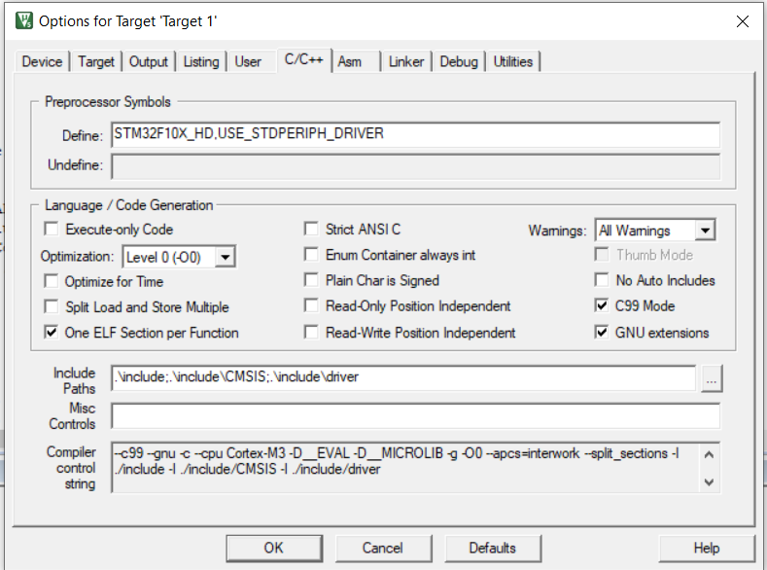

Step 2: Define preprocessor symbols and include paths

(STM32F10X_HD,USE_STDPERIPH_DRIVER)

(STM32F10X_LD,USE_STDPERIPH_DRIVER for C8)

(STM32F10X_LD,USE_STDPERIPH_DRIVER for C6)

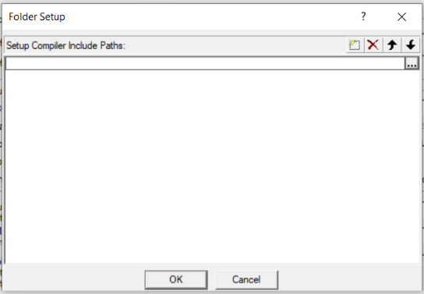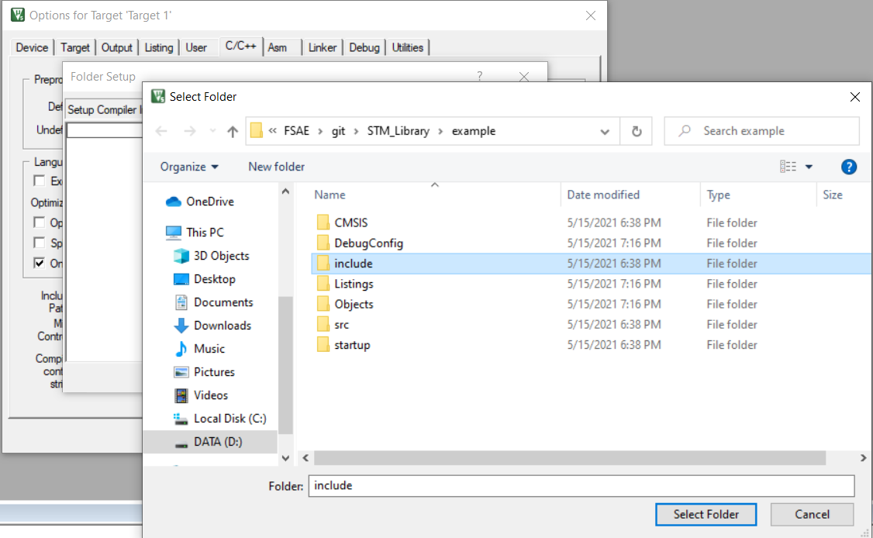

Step 2b: in this case, we should assign “include”, “include/driver” and “include/CMSIS”



Step 2c: Should end up like that

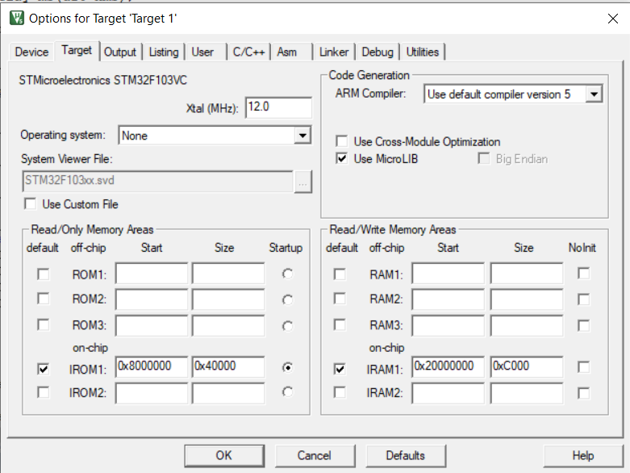

Step 3: choose MicroLib (so as to use printf)

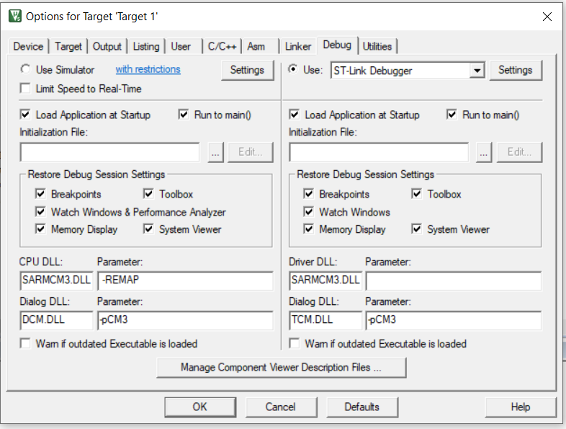

Step 4: Choose the right debugger (ST-Link in this case)

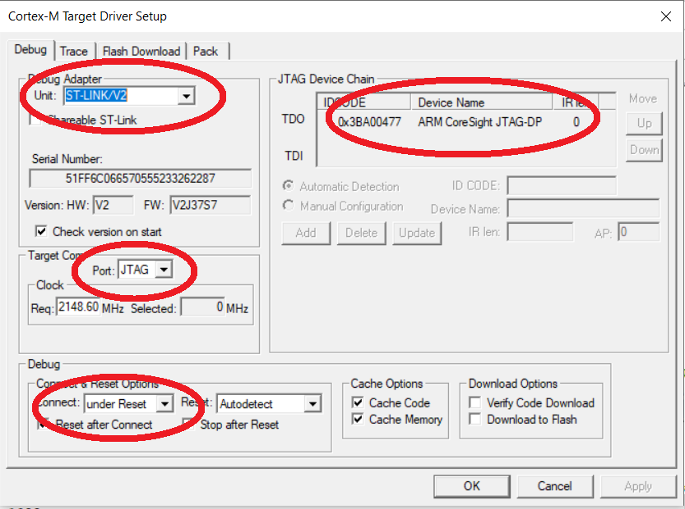

Step 4b: be aware of Port (Down left), Choose Jtag or SW,

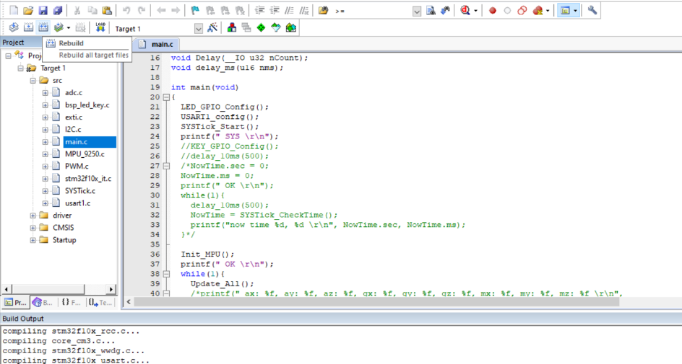

Step 5: Try to compile it with some codes

(Example codes can be found below)

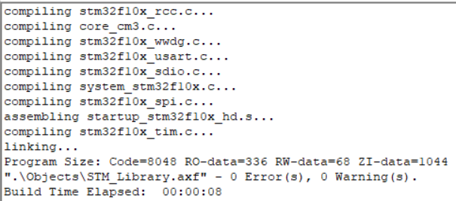

Step 6: Make it 0 Error and Warning

**c.** example: example can be arbitrary, but and is one

main.c:

#include "stm32f10x.h"

void delay_ms(u16 nms);

int main(void)

{

GPIO_InitTypeDef GPIO_InitStructure;

RCC_APB2PeriphClockCmd( RCC_APB2Periph_GPIOE, ENABLE);

GPIO_InitStructure.GPIO_Pin=GPIO_Pin_5;

GPIO_InitStructure.GPIO_Mode=GPIO_Mode_Out_PP;

GPIO_InitStructure.GPIO_Speed=GPIO_Speed_50MHz;

GPIO_Init(GPIOE, &GPIO_InitStructure);

while(1){

GPIO_SetBits(GPIOE,GPIO_Pin_5);

delay_ms(1000);

GPIO_ResetBits(GPIOE,GPIO_Pin_5);

delay_ms(1000);

}

}

void delay_ms(u16 nms)

{

u32 temp;

SysTick->LOAD = 9000*nms;

SysTick->VAL=0X00;//clear the tickle

SysTick->CTRL=0X01;//enable

do

{

temp=SysTick->CTRL;//read the tickle

}while((temp&0x01)&&(!(temp&(1<<16))));//wait for the end

SysTick->CTRL=0x00; //close it

SysTick->VAL =0X00; //clear it

}

**3. Setup your ST-Link:**

In this case, you can use ST-Link V2 to help upload codes and debug. Follow below steps to help you use the ST-Link in Keil

1. Click “Option for targets”, go to “debug” tag and choose the right debugger:

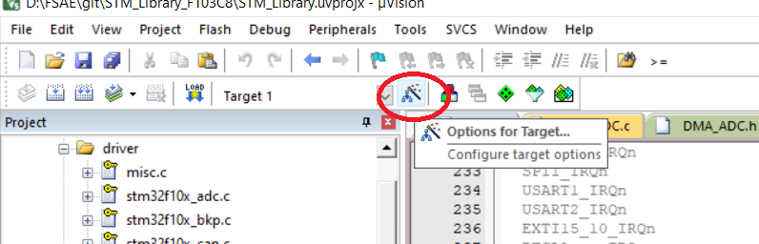

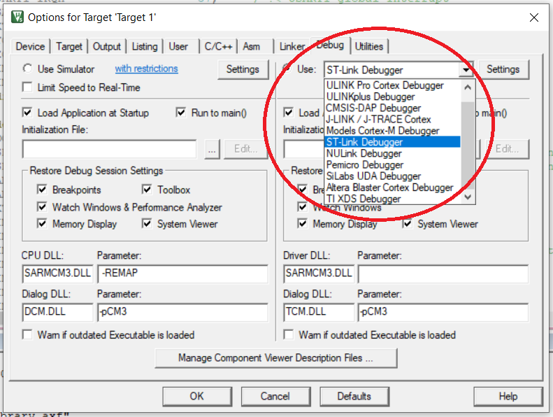

2. Enter Settings



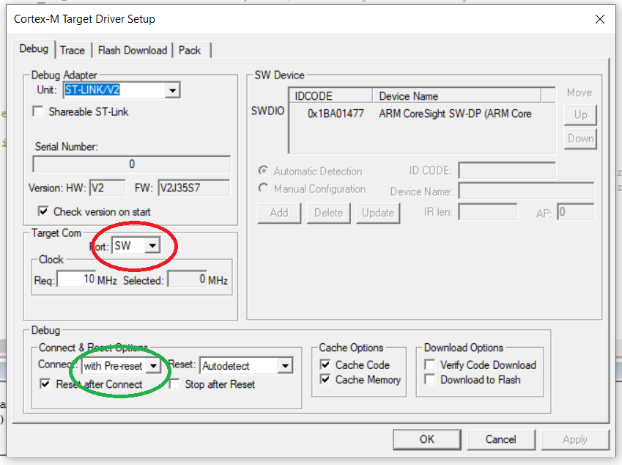

Make sure that the “port” is “SW” and the “Connect” is “with Pre-reset”.

Note that when clicking “Settings”, a dialog may jump out and help you to update the ST-Link driver. If it told you that ST-Link is in the wrong mode, please re-plugin your ST-Link and try again.

**Appendix:**

For switching to different STM32F103 type, you will need to do following steps:

Ex: from VC to C6 or C8

1. Click “Option for targets”, go to “device” tag and change device to C6



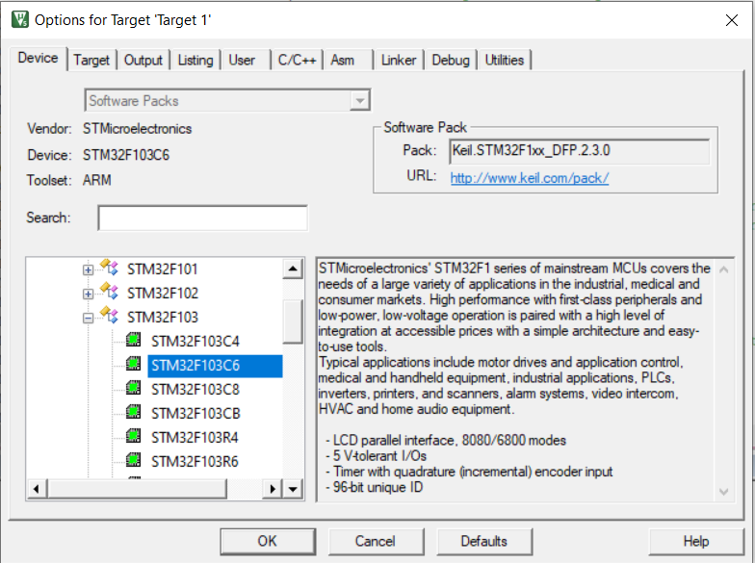

2. Go to C/C++ tag and change STM32F10X_HD to STM32F10X_LD (for C6) or STM32F10X_MD (for C8)

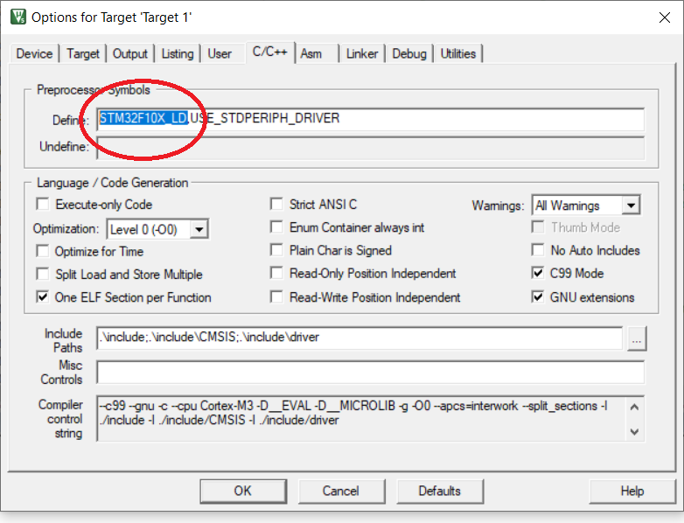

3. Go to /3.5.0/STM32F10x_StdPeriph_Lib_V3.5.0/Libraries/CMSIS/CM3/DeviceSupport/ST/STM32F10x/startup/

to find startup_stm32f10x_ld.s (for c6, and startup_stm32f10x_md.s for c8) and copy one to /startup folder under your workspace.

4. Rebuild and check.